Opdracht 5
ERD met alleen maar de PKs en FKs
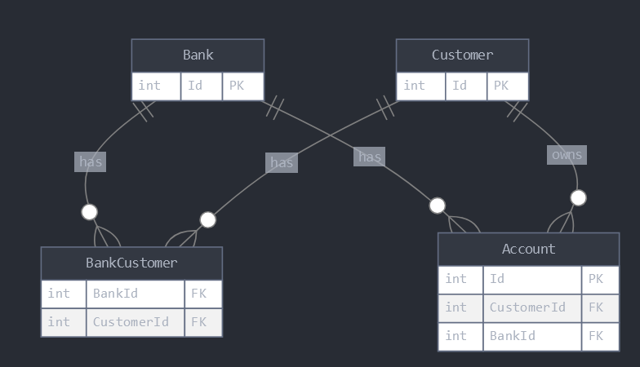

Specificatietabellen
Bank
Column name | Data type | Length | Nullable | Remark
Id | INT  Unsigned | - | No | Primary key, Auto-increment
Name | VARCHAR | 100 | No
PhoneNumber | VARCHAR | 20 | No
Email | VARCHAR | 100 | No
FoundationDate | DATE | - | No
IsActive | BIT | - | No | Default 1
Comment | TEXT | - | Yes
DateCreated | DATETIME | - | No | Default CURRENT_TIMESTAMP
DateModified | DATETIME | - | Yes | Default CURRENT_TIMESTAMP, On update CURRENT_TIMESTAMP

Customer
Column name | Data type | Length | Nullable | Remark
Id | INT  Unsigned | - | No | Primary key, Auto-increment
FirstName | VARCHAR | 50 | No
MiddleName | VARCHAR | 50 | Yes
LastName | VARCHAR | 50 | No
DateOfBirth | DATE | - | No
Mobile | VARCHAR | 20 | No
Email | VARCHAR | 100 | No
IsActive | BIT | - | No | Default: 1
Comment | TEXT | - | Yes
DateCreated | DATETIME | - | No | Default CURRENT_TIMESTAMP
DateModified | DATETIME | - | Yes | Default CURRENT_TIMESTAMP, On update CURRENT_TIMESTAMP

BankCustomer
Column name | Data type | Length | Nullable | Remark
BankId | INT  Unsigned | - | No | Foreign key referencing Bank(Id)
CustomerId | INT  Unsigned | - | No | Foreign key referencing Customer(Id)

Account
Column name | Data type | Length | Nullable | Remark
Id | INT  Unsigned | - | No | Primary key, Auto-increment
IBAN | VARCHAR | 34 | No | Unique
AccountNumber | VARCHAR | 20 | No | Unique
AccountType | VARCHAR | 50 | No
Balance | DECIMAL | (15,2) | No
OpeningDate | DATE | - | No
CustomerId | INT  Unsigned | - | Yes | Foreign key referencing Customer(Id)
BankId | INT  Unsigned | - | Yes | Foreign key referencing Bank(Id)

